

Volume 5, Number 2, February 2024

e-ISSN: 2797-6068 and p-ISSN: 2777-0915

**COMFORT VALUE OF KARTIKA SUKABUMI HOSPITAL LOBBY**

**Lilian V 1, Susetyarto B2, Puspatarini, R.A3** Fakultas Teknik Sipil Dan Perencanaan, Universitas Trisakti, Indonesia

Email: 152012210002@std.trisakti.ac.id, bambang.s@trisakti.ac.id, retna.ap@trisakti.ac.id

|  |  |
| --- | --- |
| **KEYWORDS**  space comfort, thermal comfort, visual comfort, audio comfort | **ABSTRACT**  The comfort of the hospital lobby is very influential in ensuring that health services in the hospital run optimally. Comfortable lobby conditions can reduce anxiety when patients have to wait their turn to be examined or wait for medicine from the pharmacy. Apart from that, the comfortable lobby creates optimism for recovery for patients and their families, including medical personnel who work at the hospital. This research aims to measure how significant the influence of room comfort, thermal comfort, visual comfort and audio comfort is on the comfort of the lobby room seen from the architectural design of the room. The benefits of the research enrich the results of previous research that building comfort variables influence the dynamics of perceptions of physical comfort. The research uses quantitative methods and data collection techniques are carried out by direct observation and questionnaires that are distributed to hospital visitors, managers, medical teams and patients. Data were analyzed using descriptive quantitative methods to assess the comfort level of the hospital lobby. From the results of this research, it is concluded that the aspect of freedom of movement has the greatest influence on the comfort level of the lobby space, so it must be taken into consideration when designing a hospital lobby that is comfortable for visitors. |

**INTRODUCTION**

Hospital is one of the essential healthcare facilities needed by humans. The facilities and services provided by hospitals create an image of the hospital. According to Paköz & Yüzer, the physical condition of the hospital is one of the referral criteria for hospitals (Paköz & Yüzer, 2014). The hospital's image can be seen, among other things, in the lobby area, where the lobby is the first area entered by patients when visiting the hospital (Jirajaya, 2018).

As a reception area, the lobby also has many other functions, such as an information area, waiting area, and others (Ekaputra & Sudarwani, 2014). Therefore, the lobby has a significant impact on user perceptions, and it is the architect's task to contribute to creating a space that can reduce feelings of anxiety and emotions for visitors who are in unpleasant situations (Amalia Pavita et al., 2022). In addition to focusing on medical functions, the comfort of the hospital lobby is expected to consider user comfort and help reduce stress for patients and their families (Ulrich et al., 2020). The comfort of the hospital lobby affects user image and is expected to reduce the stress effects on hospital visitors.

Building comfort has several aspects, namely spatial comfort, thermal comfort, visual comfort, and audio comfort (Kusumaningrum & Martiningrum, 2017). Kartika Medical Center Hospital is a Type D Hospital located in Sukabumi City, Indonesia. The increasing number of visitors to the hospital has resulted in the spatial comfort aspect in the lobby not being fulfilled. There are various practical functions overlapping in the lobby, such as a patient waiting area, registration area, pharmacy waiting area, cashier waiting area, and others. The addition of chairs in the lobby has caused the main entrance to be too close to the waiting area.

The research objective is to measure how significant the influence of spatial comfort, thermal comfort, visual comfort, and audio comfort on lobby space comfort is seen from the architectural design of the room. The research benefits enrich previous research results that building comfort variables affect the dynamics of physical comfort perceptions.Top of Form

**RESEARCH METHOD**

The research method used in this study is descriptive quantitative method (Sugiyono 2003). The respondents of this study amounted to 40 people, aged between 15 and 55 years old. Gender-wise, 62.9% are male and 37.1% are female. All respondents are visitors of Kartika Hospital, including patients, patient escorts, visitors, and other visitor types. The majority of respondents (57.1%) rarely visit Kartika Hospital, while 25.7% visit the hospital about 1-3 times a year. 11.4% of respondents visit the hospital 4-6 times a year, and those who visit more than 6 times a year make up 5.7%.

**RESULTS AND DISCUSSION**

Based on the formulations of building comfort theories as stipulated in the LAW OF THE REPUBLIC OF INDONESIA NUMBER 28 OF 2002 concerning Building Buildings Article 26, the requirements for building comfort include comfort in space movement and inter-space relationships, air conditions within the space, views, as well as vibration and noise levels (Presiden Republik Indonesia, 2002). Comfort in space movement refers to the level of comfort obtained from the spatial dimensions and layout that provide comfort in moving within the room. Meanwhile, comfort in inter-space relationships refers to the level of comfort obtained from the spatial layout and circulation between spaces in the building to fulfill the building's functions (Jiang & Verderber, 2017). Comfort in air conditions within the space is the level of comfort obtained from the temperature and humidity inside the space to fulfill the building's functions (Shafa et al., 2023). Comfort in views refers to the condition where individuals' privacy rights in carrying out activities within their building are not disturbed by other buildings nearby (Khamdevi et al., 2020). And comfort in vibration and noise levels is the level of comfort determined by a condition that does not disturb the users and functions of the building due to vibrations and/or noise arising from within the building or its surroundings (Amalia Pavita, Farkhan, and Kumoro Wahyuwibowo 2022). Regulations regarding comfort in space movement, inter-space relationships, air condition levels within the room, views, as well as vibration and noise levels are further regulated by Government Regulations (Kusumaningrum & Martiningrum, 2017).



**Comfort in Movement**

Comfort in spatial movement refers to the level of comfort obtained from the spatial dimensions and layout that provide comfort in moving within a room (Wismonowati, 2012). Focusing on the lobby space of Kartika Hospital, there are several issues related to capacity and user comfort in the space. Based on the observation results in Table 1, several aspects that do not meet standards can be found. The lobby has waiting chairs of good quality and in accordance with the standard sizes in Neufert, however, the arrangement of these waiting chairs is still not optimal (Neufert, 2017). The arrangement of waiting chairs has a relatively narrow distance between the front and back chairs, making it difficult for visitors to sit in middle or back rows, especially patients with physical limitations who need to use mobility aids such as crutches. Meanwhile, patients with mobility aids such as wheelchairs or strollers have difficulty finding a place to wait due to space constraints. The impact of this condition is disrupted waiting room circulation due to reduced aisle width. Placing waiting chairs only 1 meter from the main entrance door is also too close and does not meet the standard distance requirements.

Top of Form

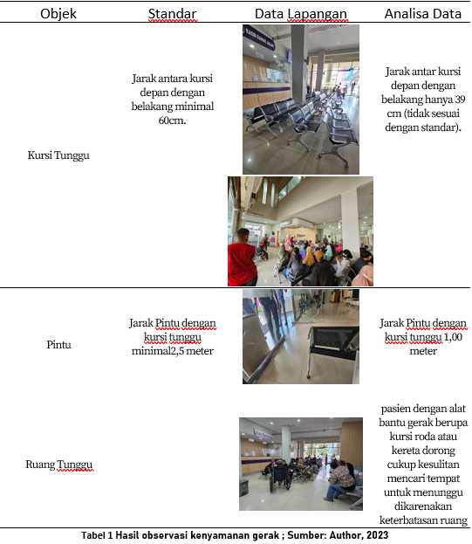

*Questionnaire results related to motion comfort*

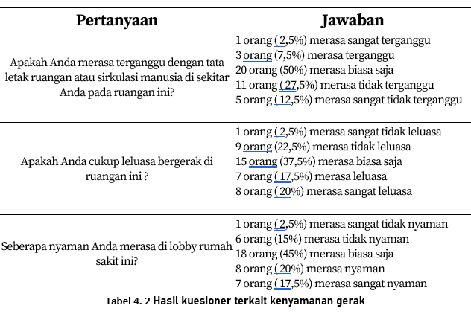

From the results of the questionnaire, it is known that there are 10% of people who feel disturbed by the layout of the surrounding room, 25% of people feel unfree and 17.5% feel uncomfortable in the lobby of this hospital. This proves the theory of space comfort, that space dimensions, room layout and circulation affect the comfort of visitors in hospital lobby rooms.

**Visual Comfort**

The level of comfort in a space is not only measured by the availability of space for users to move around. However, the visual aspect of the room also needs to be considered, especially in waiting areas, because waiting is one of the activities that can cause high levels of stress. This is where the visual aspect of the room plays an important role for users in hospital waiting areas (Hignett & Lu, 2009). Lighting is an important aspect of visual comfort. In the research location, there is both natural and artificial lighting. Table 3 shows the results of observations on the waiting room conditions in Kartika Hospital's lobby. Table 4 presents the results of a questionnaire given to 40 respondents regarding visual comfort in Kartika Hospital's lobby.

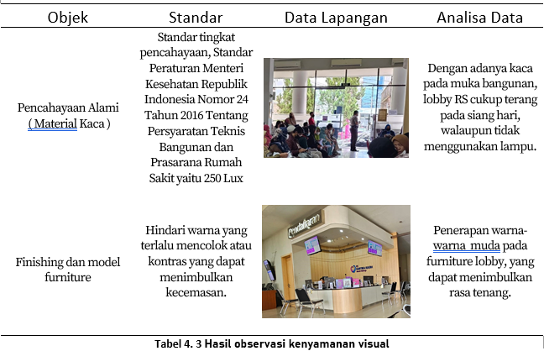

*Questionnaire results related to visual comfort*

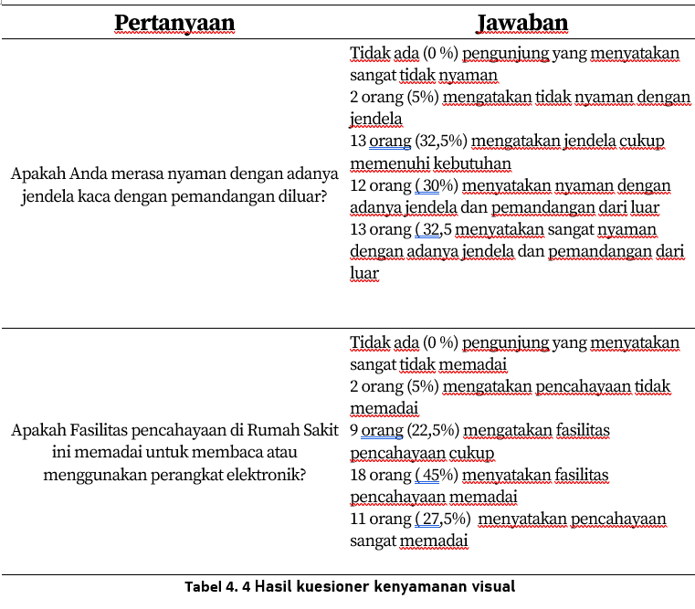

From the results of the questionnaire, it is known that most people are comfortable with natural lighting and artificial lighting in this lobby. Supported by the results of field measurements, the lighting value in the lobby reached 252lux. This is in accordance with the lighting level standard, Standard Regulation of the Minister of Health of the Republic of Indonesia Number 24 of 2016 concerning Technical Requirements for Hospital Buildings and Infrastructure, namely standard lighting is 250 Lux.

**Thermal Comfort**

The theory of thermal comfort, according to Mom & Wiesebron, states that thermal comfort levels range from cold, uncomfortable, cool, comfortable, very comfortable or optimally comfortable, comfortably warm, to uncomfortably hot. Mangunwijaya Y.B (1994) suggests that the ideal air exchange rate is 5 m2 per person per hour, and if the volume of the room is less than 5 m2 per person, the air exchange rate should be 25 m2 per person per hour (Mannan, 2007). Smooth airflow is needed to avoid the adverse effects that can harm human health in an enclosed or poorly ventilated living space. Rudi Gunawan (1981) mentioned the following adverse effects:

1. Decreased oxygen levels in the air inside the living space
2. Increased carbon dioxide levels from human respiration
3. Musty odor emitted by the skin, clothing, and mouth
4. Rise in room temperature due to body heat emitted by humans
5. Increased room humidity due to water evaporation from the skin and human respiration

For tropical climates, thermal comfort in a space can be achieved if the temperature fluctuations inside the building are relatively similar to the temperature fluctuations outside the room. (Karyono, 2016)

Top of Form

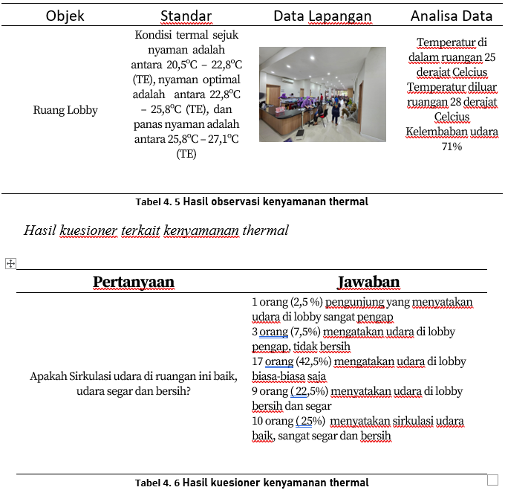

Audio Comfort The level of noise is measured in decibels (dB). The dB figure provides an indication of sound intensity. The decibel scale is logarithmic, meaning that an increase of 10 dB indicates a tenfold increase in sound intensity. In general, here are guidelines for noise levels in various contexts:

• 0 dB: Human hearing threshold, where sound is audible to most people.

• 30 dB: Soft whisper.

• 60 dB: Normal noise in office or home environments.

• 70 dB: Noisy sound, such as city traffic.

• 80 dB: Disturbing noise, such as loud machinery or music.

• 90 dB: Noise that can cause hearing damage if exposed for a long time.

• 120 dB: Pain threshold for hearing, such as gunshot noise.

As a general guide, noise levels below 70 dB are considered relatively quiet and may be considered non-disruptive. However, noise perception can vary among individuals. Some people may be disturbed by lower noise levels, while others may be more tolerant. It is important to note that when discussing noise in hospitals or healthcare environments, comfort standards may differ due to patients' sensitivity to noise. Therefore, efforts to create a quiet and comfortable environment are always prioritized in healthcare settings.

The results of noise measurements conducted in the Kartika hospital lobby are 70-80 dB. And the results of the questionnaire distributed to visitors are as follows:

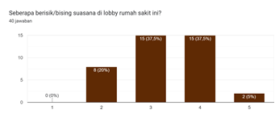

**Service Facilities**

Service in hospitals is crucial to create comfort for visitors. Hospital staff should be friendly, polite, and provide service with a smile. Good communication can help reduce anxiety and provide emotional support. Visitors need to be given clear information about procedures, wait times, and treatment processes. Easy-to-understand instructions can reduce confusion and worry. Hospital waiting rooms and lobbies should be designed to provide comfort, including comfortable seating, good lighting, and play areas for children. Providing facilities such as free WiFi, cafes or food shops, and relaxation areas can make visitors feel more comfortable and connected to the outside world. In case of emergencies, emergency services should be organized to provide quick and efficient responses. Maintaining cleanliness throughout the hospital, including patient rooms and public facilities, is crucial to prevent the spread of infections. Improving visitor comfort in hospitals is not just about medical services, but also about a holistic experience that includes the above aspects. Results of the questionnaire regarding the facilities provided by the hospital: 1 person (2.5%) felt that the facilities did not meet their needs very well, 2 people (5%) said the facilities did not meet their needs, 18 people (45%) said the lobby facilities were adequate, 12 people (30%) said the facilities met their needs, 7 people (17.5%) said the lobby facilities met the visitors' needs very well. Cleanliness is the most influential factor affecting visitor comfort, at 62.9%. Other factors are Peaceful Atmosphere (51.4%), Reception Service (48.6%), Furniture Layout (40%), Lighting (31.4%), and Other Decorations (8.6%).

***Data Analysis***

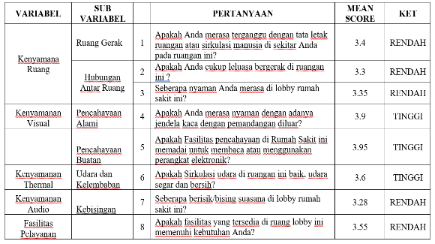

Problem formulation: High lobby room design capacity with interior arrangement that is not up to standard has an impact on decreasing space and physical comfort for hospital visitors due to limited space

Problem formulation in SPSS:

1. Is there an influence between aspects of space comfort, thermal, visual and audio formulated in 7 sub-variables on the comfort of lobby space simultaneously
2. Is there an influence between aspects of space comfort, thermal, visual and audio formulated in 7 sub-variables on the comfort of the lobby space partially

Hypothesis (Conjecture):

H0.a **=** There is no influence between aspects of space comfort, thermal, visual and audio on the comfort of the lobby space simultaneously

H1.a = There is an influence between aspects of space comfort, thermal, visual and audio on the comfort of the lobby space simultaneously

H0.b = There is no influence between aspects of space comfort, thermal, visual and audio on the comfort of the lobby space partially

H1.b = There is an influence between aspects of space comfort, thermal, visual and audio on the comfort of the lobby space partially

DECISION MAKING:

$$Y=Kenyamanan ruang Lobby$$

$$X_{1}=Tata Letak Ruang Gerak$$

$$X_{2}=Keleluasaan Bergerak$$

$$X_{3}=Pencahayaan alami$$

$$X_{4}=Pencahayaan buatan$$

$$X_{5}=Udara dan Kelembaban$$

$$X_{6}=Kebisingan$$

$$X_{7}=Fasilitas pelayanan$$

Through multiple regression analysis with SPSS, the regression equation can be arranged as follows:

$${Y=a+bX}_{1}+cX_{2}+dX_{3}+eX_{4}+{fX}_{5}+gX_{6}+hX_{7}+e$$

The results obtained through statistical analysis with SPSS software are obtained as follows:



Answer the first question:

To see the influence simultaneously or collectively on . Decision Making uses two ways, namely: $x_{1}, x_{2}, x_{3}, ⋯, x_{7}y$

Method 1:

$$jika Sig>0,05 maka H_{0} diterima$$

$$dan jika Sig<0,05 maka H_{0} ditolak$$

Based on the ANOVA table, a Sig value of 0.000 was obtained, so it was < 0.05 so it was rejected $H_{0}$

Method 2:

$$jika F hitung< tabel maka H_{0} diterima$$

$$dan jika F hitung>F tabel maka H_{0} ditolak$$

F table obtained from

$\left(V_{1}=k; V_{2}=n-k-1\right) maka \left(V_{1}=7; V_{2}=40-7-1=32\right)$ $\left(V_{1}=k; V_{2}=n-k-1\right) maka \left(V_{1}=7; V_{2}=40-7-1=32\right)$

with the value obtained the F value of the table is 2.31 while the calculated F value is obtained from the Anova table of 22.366. Thus then $V_{1}=7 dan V_{2}=32F hitung>F tabelH_{0} ditolak$

***It was concluded based on these two methods simultaneously that there is a significant influence between aspects of space comfort, thermal, visual and audio on the comfort of the lobby space.***

Answer the second question:

To see the effect partially or individually for each independent variable up to decision making, two ways are used as the first question $X_{1}X_{7}y$.

Method 1:

$$jika Sig>0,05 maka H_{0} diterima dan jika Sig<0,05 maka H_{0} ditolak$$

Based on the ANOVA table, a Sig value of 0.000 was obtained, so it was < 0.05 so it was rejected $H_{0}$

Method 2:

**For X1 Movement Space on Lobby Comfort Level y**

Method 1 Obtained results based on ANOVA table yielded a Sig value of 0.000 which is < 0.05 hence $H_{0}$ is rejected

Method 2 on the t table value, a two-sided test can be determined with a two-sided test of , then the t-table value is obtained at 2.022 while the calculated t-value is obtained from the Coefficients table in the $X_{1}$ movement space row, which is $0,751$ Since the calculated t-value < t-table, then $H_{0} diterima$ thus it can be concluded that there is no significant influence between the movement space layout on lobby comfort.

**For $X_{2}$ Mobility Freedom on Lobby Comfort Level $y$**

Method 1 Obtained results based on ANOVA table yielded a Sig value of 0.000 which is < 0.05 hence $H_{0}$ is rejected

Method 2 on the t table value, a two-sided test can be determined with a two-sided test of, then the t-table value is obtained at 2.022 while the calculated t-value is obtained from the Coefficients table in the $X_{2}$ space relationship row, which is $2,878$

Since the calculated t-value > t-table, then $H_{0} rejected$ thus it can be concluded that there is a significant influence between mobility freedom on lobby comfort.

**For $X_{3}$ Natural Lighting on Lobby Comfort Level $y$**

Method 1 Obtained results based on ANOVA table yielded a Sig value of 0.000 which is < 0.05 hence is rejected

Method 2 on the t table value, a two-sided test can be determined with a two-sided test of , then the t-table value is obtained at 2.022 while the calculated t-value is obtained from the Coefficients table in the $X_{3}$ natural lighting row, which is $-0,088$ Since the calculated t-value < t-table, then $H_{0} Accepted$ thus it can be concluded that there is no significant influence between natural lighting on lobby comfort.

**For $X_{4}$ Artificial Lighting on Lobby Comfort Level $y$**

Method 1 Obtained results based on ANOVA table yielded a Sig value of 0.000 which is < 0.05 hence is rejected

Method 2 on the t table value, a two-sided test can be determined with a two-sided test of , then the t-table value is obtained at 2.022 while the calculated t-value is obtained from the Coefficients table in the $X_{4}$ artificial lighting row, which is $-0,090$ Since the calculated t-value < t-table, then $H_{0} Accepted$ thus it can be concluded that there is no significant influence between artificial lighting on lobby comfort.

**For $X_{5}$ Air and Humidity on Lobby Comfort Level $y$**

Method 1 Obtained results based on ANOVA table yielded a Sig value of 0.000 which is < 0.05 hence $H_{0}$ is rejected

Method 2 on the t table value, a two-sided test can be determined with a two-sided test of , then the t-table value is obtained at 2.022 while the calculated t-value is obtained from the Coefficients table in the $X_{5}$ air and humidity row, which is $0,856$

Since the calculated t-value < t-table, then $H_{0} Accepted$ thus it can be concluded that there is no significant influence between air and humidity on lobby comfort.

**For $X_{6}$ Noise on Lobby Comfort Level $y$**

Method 1 Obtained results based on ANOVA table yielded a Sig value of 0.000 which is < 0.05 hence $H_{0}$ is rejected

Method 2 on the t table value, a two-sided test can be determined (df=n-1=40-1=39) with a two-sided test of $\frac{0,05}{2}=0,025$, then the t-table value is obtained at 2.022 while the calculated t-value is obtained from the Coefficients table in the $X_{6}$ noise row, which is $0,839$

Since the calculated t-value < t-table, then $H_{0} Accepted$ thus it can be concluded that there is no significant influence between noise on lobby comfort.

**For $X_{7}$ Service Facilities on Lobby Comfort Level $y$**

Method 1 Obtained results based on ANOVA table yielded a Sig value of 0.000 which is < 0.05 hence $H_{0}$ is rejected

Method 2 on the t table value, a two-sided test can be determined with a two-sided test of , then the t-table value is obtained at 2.022 while the calculated t-value is obtained from the Coefficients table in the $X_{7}$ service facilities row, which is $1,137$

Since the calculated t-value < t-table, then $H_{0} Accepted$ thus it can be concluded that there is no significant influence between service facilities on lobby comfort.

Based on the *Coefficients table****,***  a regression model is obtained, namely:

$$y=-0,012+0,137{ X}_{1}+0,479 X_{2}-0,012 X_{3}-0,011 X_{4}+0,151 X_{5}+0,095 X_{6}+0,155 X_{7}+e$$

If viewed partially, what affects the comfort of the lobby space is the freedom to move ${(X}_{2})$. So if the aspect of freedom of movement increases then the comfort level of lobby space will increase by 0.137 assuming other variables are constant. It can also be seen in the Model Summary table, the R square column is the squaring of the R value, that is, this R square can also be expressed as a coefficient of determination, meaning that the comfort level of the lobby space is influenced by 83% by the variable of freedom of movement, while the rest is influenced by 6 other variables $\left(0,911×0,911=0,830\right)X_{2}$.

**CONCLUSION**

Overall, it can be concluded that the results showed that there was no significant influence between the layout of the space, natural lighting, artificial lighting, air and humidity, noise, and service facilities on the comfort of the lobby space. However, there is a significant influence of freedom of movement on the comfort of lobby space. Partially, the variable of freedom of movement is the most influential on the comfort of the lobby space, affecting 83%, while the rest is influenced by other variables. In addition, simultaneously, aspects of space comfort, thermal, visual, and audio significantly affect the comfort of the lobby space.

**REFERENCES**

Amalia Pavita, J., Farkhan, A., & Kumoro Wahyuwibowo, A. (2022). Penerapan Arsitektur Perilaku Pada Rumah Sakit Umum Tipe C Dan Fasilitas Isolasi Di Semarang. *Juli*, *5*(2), 450–461.

Ekaputra, Y. D., & Sudarwani, M. M. (2014). *Karakteristik Ruang Tunggu pada Instalasi Rawat Jalan … (Ekaputra dan Sudarwani)*. *340*, 20–25.

Hignett, S., & Lu, J. (2009). An investigation of the use of health building notes by UK healthcare building designers. *Applied Ergonomics*, *40*(4), 608–616. https://doi.org/10.1016/j.apergo.2008.04.018

Jiang, S., & Verderber, S. (2017). On the Planning and Design of Hospital Circulation Zones: A Review of the Evidence-Based Literature. *Health Environments Research and Design Journal*, *10*(2), 124–146. https://doi.org/10.1177/1937586716672041

Jirajaya, T. K. (2018). Kajian Desain Interior Lobby Rumah Sakit Mitra Keluarga di Surabaya. *Jurnal Intra*, *7*(1), 1–9.

Karyono, T. H. (2016). *Kenyamanan Termal Dan Penghematan Energi : Teori Dan Kenyamanan Termal Dan Penghematan Energi : Teori Dan*. *March 2010*.

Khamdevi, M., Kurniawan, G., Wahyudi, T., Marcellino, L., & Pratama, A. (2020). Pengaruh Desain Lobby Universitas Matana Terhadap Kenyamanan Termal, Visual, Akustik, dan Kesehatan. *MARKA (Media Arsitektur Dan Kota) : Jurnal Ilmiah Penelitian*, *3*(2), 83–93. https://doi.org/10.33510/marka.2020.3.2.83-93

Kusumaningrum, A., & Martiningrum, I. (2017). Persepsi Pengunjung terhadap Tingkat Kenyamanan Bangunan Pelayanan Kesehatan. *Jurnal Mahasiswa Jurusan Arsitektur*, *5*(4).

Mannan. (2007). *FAKTOR KENYAMANAN DALAM PERANCANGAN BANGUNAN (KENYAMANAN SUHU-TERMAL PADA BANGUNAN)*.

Neufert, E. and P. (2017). *Neufert Architects’ Data*.

Paköz, M. Z., & Yüzer, M. A. (2014). Access to healthcare: A field survey in Istanbul. *A/Z ITU Journal of the Faculty of Architecture*, *11*(2), 271–290.

Presiden Republik Indonesia. (2002). Undang-Undang Republik Indonesia tentang Bangunan Gedung. *Undang-Undang Republik Indonesia Nomor 28 Tahun 2002 Tentang Bangunan Gedung*, *1*, 1–5.

Shafa, A., Hardiman, G., & Budi, W. S. (2023). Kajian Sistem Penghawaan terhadap Kenyamanan Termal pada Rumah Produksi Tenun Bukan Mesin. *Arsitektura*, *21*(1), 01. https://doi.org/10.20961/arst.v21i2.63117

Ulrich, R. S., Cordoza, M., Gardiner, S. K., Manulik, B. J., Fitzpatrick, P. S., Hazen, T. M., & Perkins, R. S. (2020). ICU Patient Family Stress Recovery During Breaks in a Hospital Garden and Indoor Environments. *Health Environments Research and Design Journal*, *13*(2), 83–102. https://doi.org/10.1177/1937586719867157

Wismonowati, D. (2012). Kajian Tingkat Kenyamanan Fisik Ruang Dalam Berdasarkan Persepsi Pengguna. *Universitas Negeri Semarang*, 34–35.

Amalia Pavita, J., Farkhan, A., & Kumoro Wahyuwibowo, A. (2022). Penerapan Arsitektur Perilaku Pada Rumah Sakit Umum Tipe C Dan Fasilitas Isolasi Di Semarang. *Juli*, *5*(2), 450–461.

Ekaputra, Y. D., & Sudarwani, M. M. (2014). *Karakteristik Ruang Tunggu pada Instalasi Rawat Jalan … (Ekaputra dan Sudarwani)*. *340*, 20–25.

Hignett, S., & Lu, J. (2009). An investigation of the use of health building notes by UK healthcare building designers. *Applied Ergonomics*, *40*(4), 608–616. https://doi.org/10.1016/j.apergo.2008.04.018

Jiang, S., & Verderber, S. (2017). On the Planning and Design of Hospital Circulation Zones: A Review of the Evidence-Based Literature. *Health Environments Research and Design Journal*, *10*(2), 124–146. https://doi.org/10.1177/1937586716672041

Jirajaya, T. K. (2018). Kajian Desain Interior Lobby Rumah Sakit Mitra Keluarga di Surabaya. *Jurnal Intra*, *7*(1), 1–9.

Karyono, T. H. (2016). *Kenyamanan Termal Dan Penghematan Energi : Teori Dan Kenyamanan Termal Dan Penghematan Energi : Teori Dan*. *March 2010*.

Khamdevi, M., Kurniawan, G., Wahyudi, T., Marcellino, L., & Pratama, A. (2020). Pengaruh Desain Lobby Universitas Matana Terhadap Kenyamanan Termal, Visual, Akustik, dan Kesehatan. *MARKA (Media Arsitektur Dan Kota) : Jurnal Ilmiah Penelitian*, *3*(2), 83–93. https://doi.org/10.33510/marka.2020.3.2.83-93

Kusumaningrum, A., & Martiningrum, I. (2017). Persepsi Pengunjung terhadap Tingkat Kenyamanan Bangunan Pelayanan Kesehatan. *Jurnal Mahasiswa Jurusan Arsitektur*, *5*(4).

Mannan. (2007). *FAKTOR KENYAMANAN DALAM PERANCANGAN BANGUNAN (KENYAMANAN SUHU-TERMAL PADA BANGUNAN)*.

Neufert, E. and P. (2017). *Neufert Architects’ Data*.

Paköz, M. Z., & Yüzer, M. A. (2014). Access to healthcare: A field survey in Istanbul. *A/Z ITU Journal of the Faculty of Architecture*, *11*(2), 271–290.

Presiden Republik Indonesia. (2002). Undang-Undang Republik Indonesia tentang Bangunan Gedung. *Undang-Undang Republik Indonesia Nomor 28 Tahun 2002 Tentang Bangunan Gedung*, *1*, 1–5.

Shafa, A., Hardiman, G., & Budi, W. S. (2023). Kajian Sistem Penghawaan terhadap Kenyamanan Termal pada Rumah Produksi Tenun Bukan Mesin. *Arsitektura*, *21*(1), 01. https://doi.org/10.20961/arst.v21i2.63117

Ulrich, R. S., Cordoza, M., Gardiner, S. K., Manulik, B. J., Fitzpatrick, P. S., Hazen, T. M., & Perkins, R. S. (2020). ICU Patient Family Stress Recovery During Breaks in a Hospital Garden and Indoor Environments. *Health Environments Research and Design Journal*, *13*(2), 83–102. https://doi.org/10.1177/1937586719867157

Wismonowati, D. (2012). Kajian Tingkat Kenyamanan Fisik Ruang Dalam Berdasarkan Persepsi Pengguna. *Universitas Negeri Semarang*, 34–35.

**Copyright holders:**

**Lilian V, Susetyarto B, Puspatarini, R.A (2024)**

**First publication right:**

**Devotion - Journal of Research and Community Service**

**[](https://creativecommons.org/licenses/by-sa/4.0/)**

**This article is licensed under a**[**Creative Commons Attribution-ShareAlike 4.0 International**](https://creativecommons.org/licenses/by-sa/4.0/)